2.90: a) Suppose that Superman falls for a time t, and that the student has been
falling for a time t₀ before Superman’s leap (in this case, t₀ = 5 s). Then, the height h of the building is related to t and t₀ in two different ways:
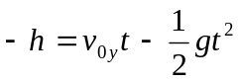
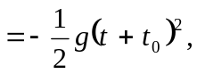

where v_{0y} is Superman’s initial velocity. Solving the second t gives 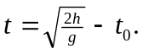 Solving the first for v_{0y} gives v_{0y} = 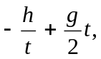 and substitution of numerical values gives t = 1.06 s and v_{0y} = –165 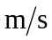, with the minus sign indicating a downward initial velocity.

b)
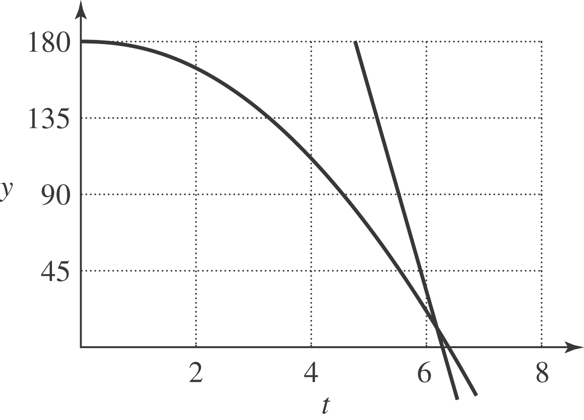

c) If the skyscraper is so short that the student is already on the ground, then 